English c.w 3/9/25
1)Pick out the verbs ( action word) in the given passage:
Sani and Sonal are friends. They play together in the park. Sani runs fast and Sonal jumps high. They laugh and have fun.

Ans –__________________________________________________

2) Look at the picture below and name the noun you can see :

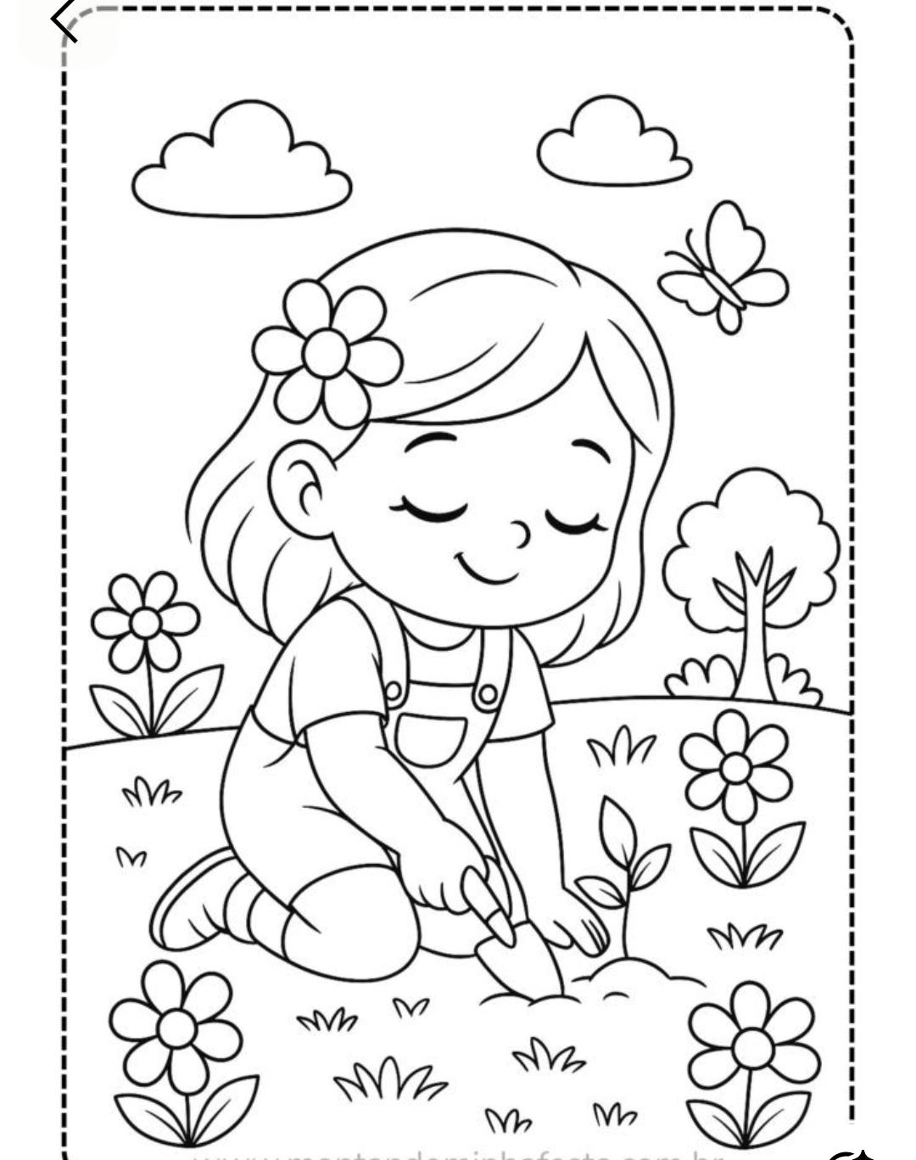

Singular | Plural

